Chapter 10, Solution 56.

- To find 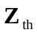, consider the circuit in Fig. (a).
(a)
j4 W
6 W
Z_{th}
-j2 W

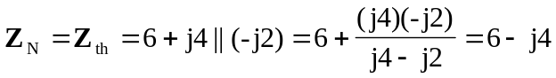
= 7.211Ð-33.69° W

By placing short circuit at terminals a-b, we obtain,
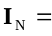 2Ð0° A

14.422Ð-33.69° V
Z_{th}
j10 W
60 W
-j5 W
(b)
30 W
- To find , consider the circuit in Fig. (b).

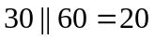
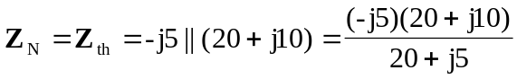
= 5.423Ð-77.47° W

To find 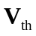 and , we transform the voltage source and combine the 30 W and 60 W resistors. The result is shown in Fig. (c).
20 W
(c)
j10 W
-j5 W
4Ð45° A
I_{N}
a

b

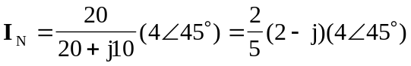
= 3.578Ð18.43° A

= 19.4Ð-59° V

